|  |  |  |  |  |
| --- | --- | --- | --- | --- |
| Project details | | | | |
| **TEAM NAME:** |  | | | |
| **PROJECT NAME:** |  | | | |
| **SCHOOL NAME:** |  | | | |
| **SCHOOL ADDRESS:** |  | | | |
|  |
|  |
|  |  | | **EMAIL ADDRESS** | **PHONE** |
| **TEACHER’S NAME:** |  | |  |  |
|  |  | |  |  |
| **MENTOR’S NAME:** |  | |  |  |
|  |  | |  |  |
| **STUDENT PARTICIPANT’S NAMES:** |  | |  |  |
|  |  | |  |  |
|  |  | |  |  |
|  | **Activity** | | **Time Duration** | **Starting Date** |
| **WEEKLY PROGRESS: Documenting the project's development journey, showcasing the design process, and illustrating progress through photos, posters, and charts.** |  | |  |  |
|  |  |  | |  |
|  |  |  | |  |

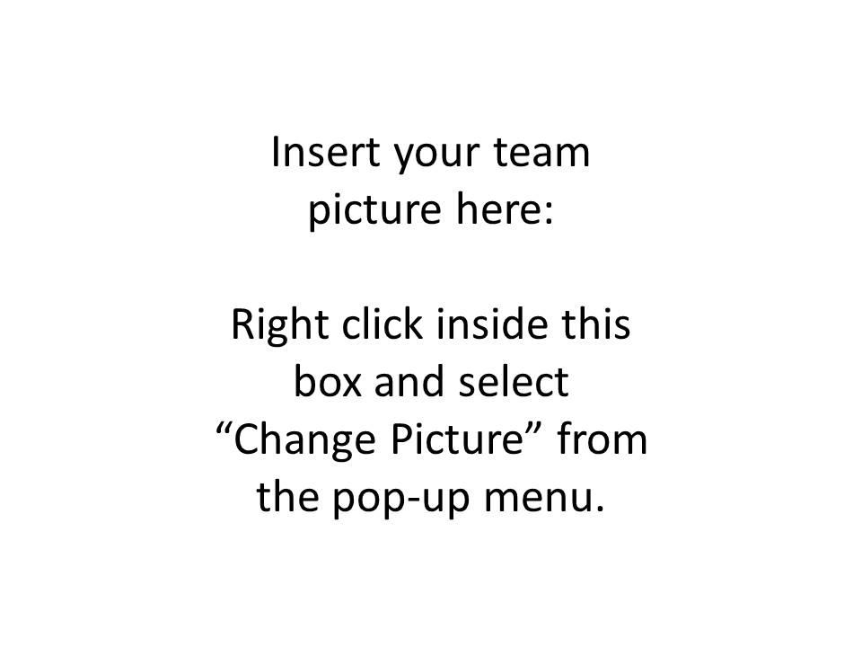**INSERT TEAM PICTURE:**

**General Notes:**

1. You are advised to document all recording activities thoroughly.
2. Insert charts, graphs, and pictures that illustrate research and data, reflecting your work.
3. The logbook should clearly outline planning assignments, individual responsibilities, and each member’s contribution.
4. Ensure logbook contains all activities performed by the team members.
5. In addition to text, images, graphs, charts, research information, copies of detailed reports etc. can be included in the logbook.